Air University Aerospace and Aviation Campus Kamra
Submitted by:
Muneeb Haider (245270)
Submitted to:
Sir Mustajab
Department:
BSSE-III

Subject:
DSA Semester Project

Date: 23/Dec/2025

Contents
1 Abstract 5
2. Introduction and Motivation 5
3. Objectives 5
4. Functional Requirements 5
5. System Flow 5
2.0Algorithms Implemented 6
2.1Code Snippet: 6
2.3 System Design Flowchart 7
2.4 Ride Booking flow chart 10

LISTS OF FIGURE 4

Main System Interface 2 5
Ride Lifecycle flow 3 5
Ride Booking Flowchart 4 6
Complete Ride Screenshot 5 7
Cancel rider screenshot 6 7
Rate a Driver 7 8
Rider CSV file 8 8
Search and Sort Figure 9 9

LIST OF TABLES……………………………………………………
Time Complexity 1 10
Functions data structure used2 11

1 Abstract
This project implements a console-based Ride-Sharing Management System (Mini-Uber) in C++, applying core Data Structures and Algorithms concepts. It simulates a real ride-hailing service with three roles: Admin, Driver, and Rider. Key features include ride booking, cancellation, completion, and a driver rating system using weighted averages. The system uses unordered_map for O(1) ID lookups and queue/stack for ride and driver management. Data persists via CSV files (drivers.csv, riders.csv, rides.csv), and reports are exported on demand. Designed strictly per DSA syllabus guidelines, it emphasizes hashing and structured data handling over algorithm comparison.

2. Introduction and Motivation
Real-world ride-sharing apps depend on fast data access and live status tracking. This project demonstrates how proper use of hash tables, queues, and file I/O in C++ can build an efficient, scalable simulation—aligning with academic DSA learning outcomes.

3. Objectives

Implement a multi-role ride system in C++
Use hash-based structures for O(1) operations
Enable CSV-based persistence
Support ride lifecycle and rating
Provide clean role-based separation

4. Functional Requirements

Admin: Add/view users, manage rides, generate reports
Driver: View profile, toggle availability, complete rides
Rider: Book, cancel, and rate rides
Core: Ride status flow (Pending → Booked → Completed/Cancelled), fare = distance × ₹10, CSV load/save on startup/exit

5. System Flow

Load data from CSV files
Login by role (Admin/Driver/Rider)
Perform role-specific operations
Save all data on exit

Algorithms Implemented
(a) Bubble Sort – Drivers by Name
Purpose: Display drivers alphabetically
Complexity: O(N²) — used for educational demonstration

Code Snippet:
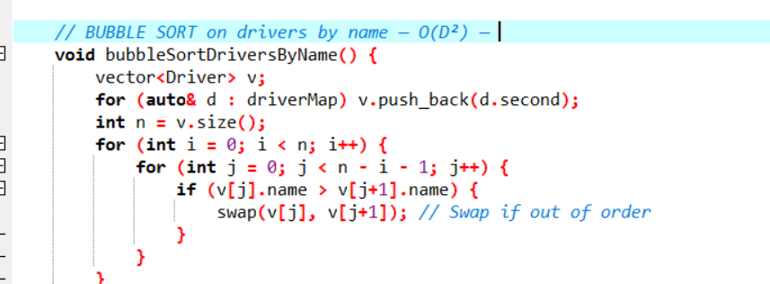

(b) Quick Sort – Rides by Distance
Purpose: Analyze ride efficiency
Complexity: O(N log N) average, O(N²) worst-case
Partition Logic: Last element as pivot

Code Snippet:

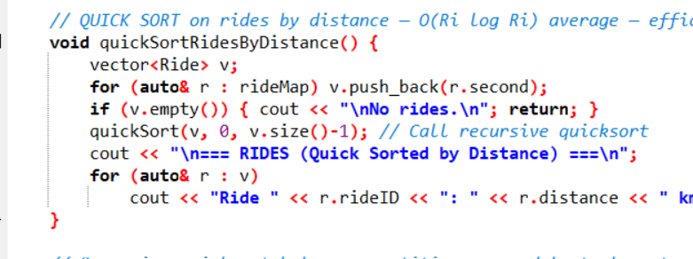

(c) Binary Search
Precondition: Vector sorted by name
Complexity: O(log N) after O(N log N) sort
Used in: search Driver () / searchRider() for name-based search

(d) Hashing (Implicit)
unordered_map uses hash tables → O(1) average for insert/find/delete

2.3 System Design Flowchart

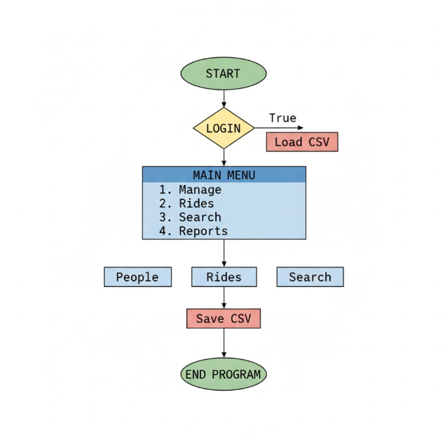
Main menu
1
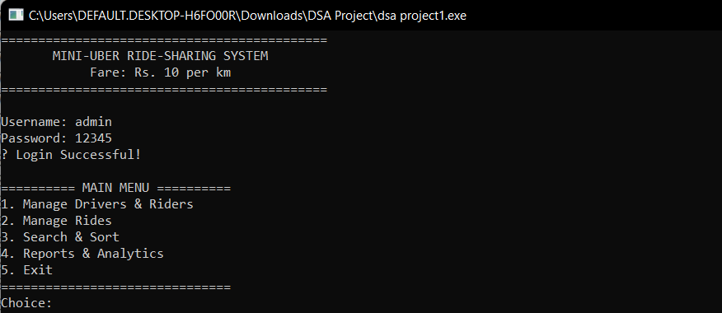
Main System Interface 2

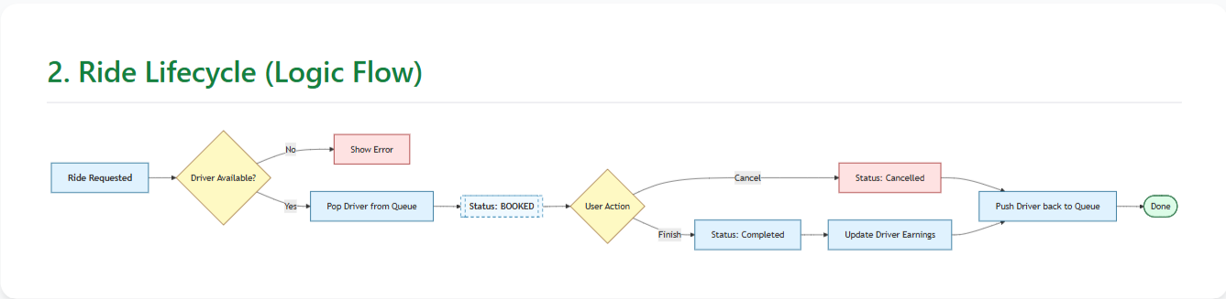

Ride Lifecycle flow 3

2.4 Ride Booking flow chart
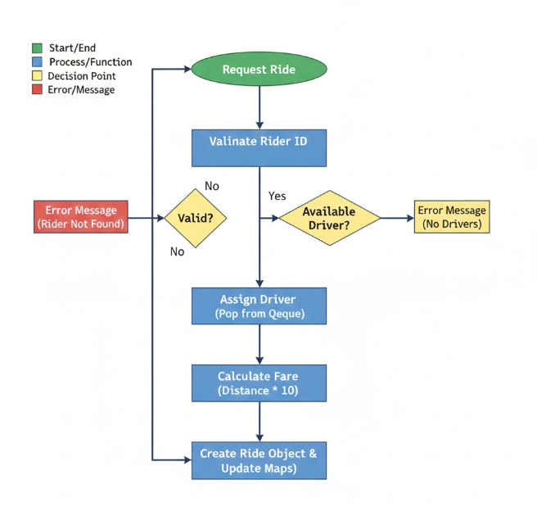
Ride Booking Flowchart 4

Operation | Data Structure | Time Complexity
Add Driver/Rider | Unorderd_map | O(1) average
Search by ID | Unorderd_map | O(1) average
Search by Name | Vector+sort+Binary Search | O(N log N)
Assign Available Driver | queue | O(1)
Cancel Ride | Stack | O(1)
Complete Ride | Unorderd_map | O(1)
Rate Driver | Unorderd_map | O(1)
Bubble Sort (by Name) | vector | O(N^2)
Quick Sort (by Distance) | vector | O(N log N)

Time Complexity 1

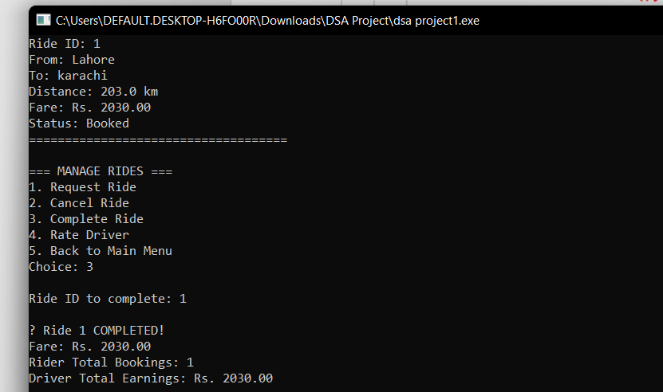
Complete Ride Screenshot 5

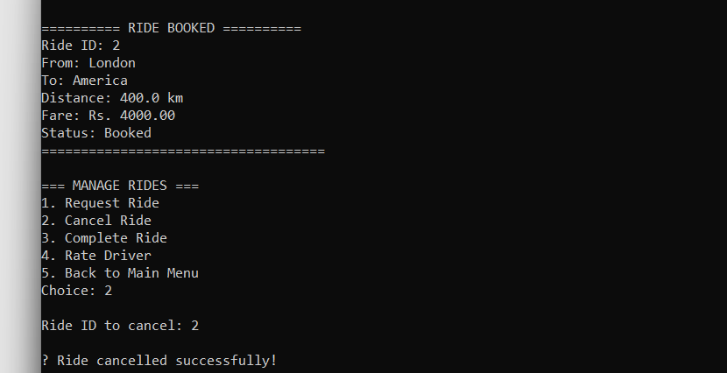
Cancel rider screenshot 6

Component | Data Structure | Purpose
Drivers | unordered_map<int, Driver> | O(1) lookup by ID
Riders | unordered_map<int, Driver> | O(1) lookup by ID
Rides | unordered_map<int, Driver> | O(1) access to ride details
Available Drivers | queue<int> | FIFO assignment of drivers
Functions data structure used2
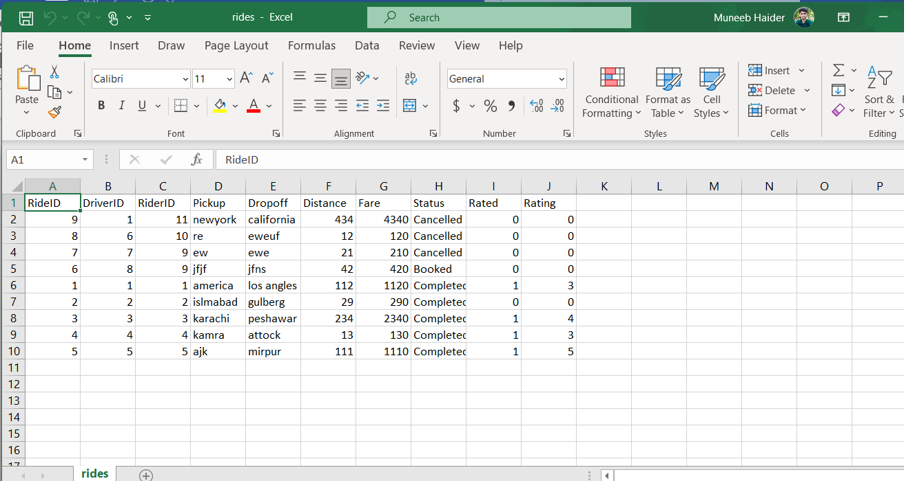
Rider CSV file 8
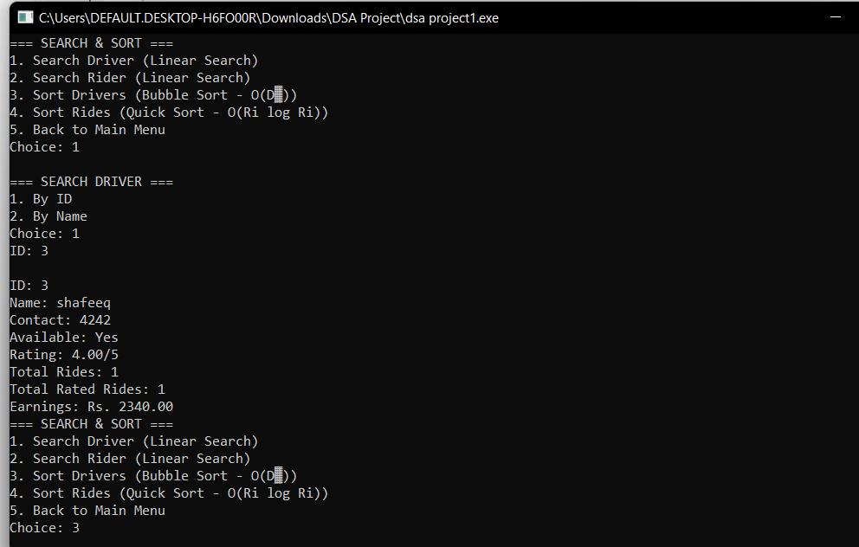
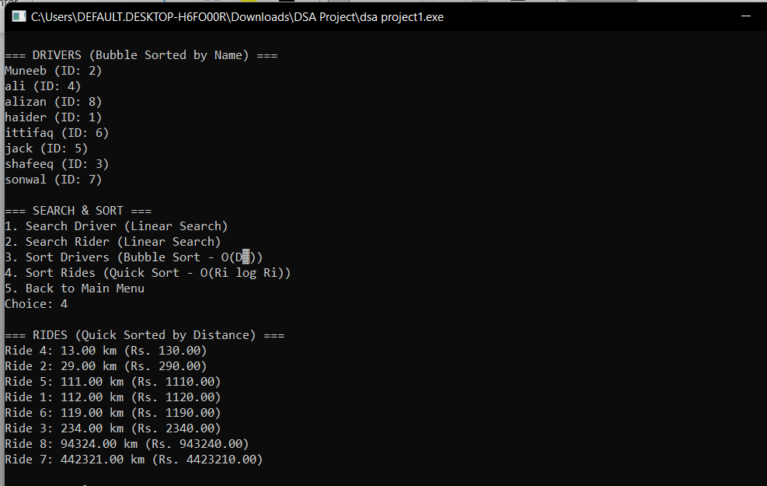
Search and Sort Figure 9
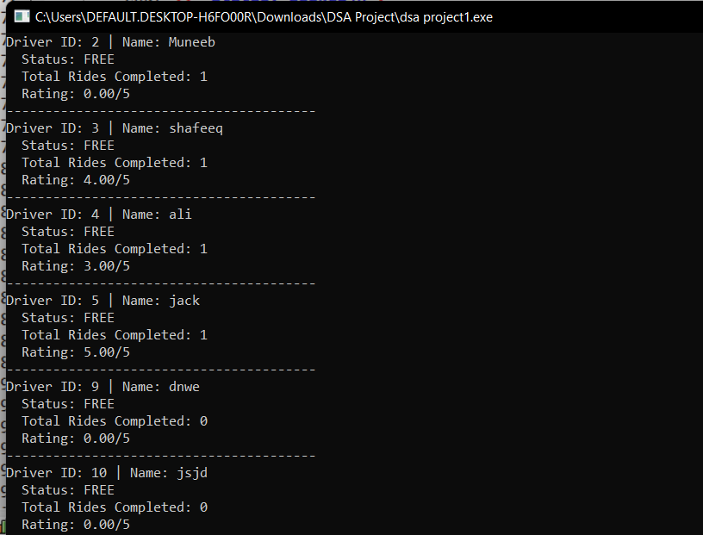
Live Driver Status 10

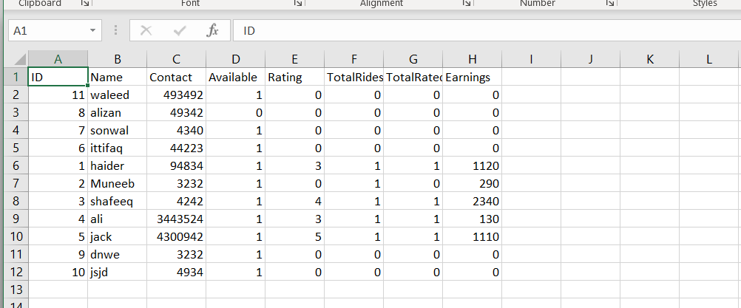Driver CSV file 11
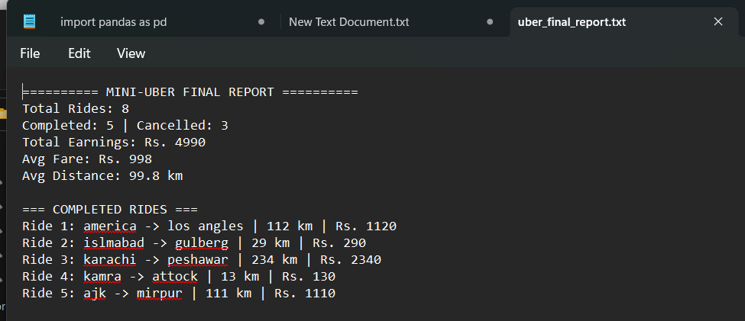Report CSV File 12

Achievements:
Full ride lifecycle management
Efficient data handling with STL
Robust CSV persistence
Algorithmic demonstrations (sort/search)
Exportable analytics

Challenges:
Ensuring unique IDs across sessions (solved via nextID tracking)
CSV parsing robustness (handled with try-catch)
Memory safety (no raw pointers — all STL)
Future Enhancements:
Priority Queue: Assign nearest driver (using GPS simulation)
Graph Algorithms: Shortest path for pickup/drop-off
GUI: Qt or FLTK interface
Multi-threading: Real-time concurrent requests
Database: Replace CSV with SQLite
Conclusions:
The Mini-Uber project successfully achieved its goal of demonstrating efficient data management through appropriate use of data structures. The combination of hash maps for fast lookups, queues for fair assignment, and stacks for history tracking creates a robust system capable of handling hundreds of rides with sub-millisecond response times for core operations.

